

**The Impact of Stephen Curry on 3- pointers in NBA:**

**A Statistical Study**

IE- 6200 Team Project

College of Engineering, Northeastern University

Karthika Nambiar, Mahendra Nanuram Kaswan, Manoj Kumar Mahendra, Nijin Varghese, Pranjal Yadav

December 9, 2021

**TABLE OF CONTENTS**

|  |  |  |
| --- | --- | --- |
| **S. NO.** | **TITLE** | **PAGE** |
| 1. | ABSTRACT | 2 |
| 2. | METHODOLOGY | 2 |
| 3. | P- DIAGRAM | 3 |
| 4. | DATA | 4 |
| 5. | DESCRIPTIVE STATISTICAL DATA | 5 |
| 6. | TIME- SERIES | 6 |
| 7. | BOX- PLOT | 8 |
| 8. | HISTOGRAM | 10 |
| 9. | T-TEST (HYPOTHESIS TESTING) | 12 |
| 10. | ANOVA | 14 |
| 11. | RESULTS AND DISCUSSION | 16 |
| 12. | SCOPE OF WORK | 16 |
| 13. | REFERENCES | 17 |

1. **ABSTRACT**

Stephen Curry is a professional basketball player for the Golden State Warriors of the National Basketball Association (NBA). He is popularly known as the '3-pointer god' and widely regarded as the most excellent shooter in NBA history with a track record of 7 All-star selections, 2 MVP awards, and 3 NBA championships. A three-point field goal in a basketball game is scored from a designated arc surrounding the basket beyond the three-point line. A successful attempt is worth three points, in contrast to the two points awarded for field goals made within the three-point line and the one point for each made free throw. Before Stephan's arrival, 3-point shots had an average increase of 1.31% each season, and post his arrival, the average increase was 6.70%. We have used a time graph, histogram, and ANOVA (1996-2020) to analyze the trend of 3 points shooting from over 30 NBA teams and Stephan Curry's contribution to the Golden State Warriors before and after his arrival to the NBA.

1. **METHODOLOGY**

The data analysis for 3-point shooting is made by selecting 30 NBA teams within 1996-2020. The four main factors that we focus on are

* 3- pointers scored
* 3- pointers attempted
* 3-pointers field goal percentage and
* Share of 3- pointers in total points

We developed a p-diagram to better understand the factors which come into play while shooting a 3 pointer. We considered several factors such as the control, noise, and input/output factors. A time-series graph is plotted to determine the trends of 3-point shooting before and after Stephan Curry’s arrival. He was made the role player in the year 2011, and since then, we can notice the exponential increase in the four parameters mentioned above. Time series analysis is mainly used to discover a pattern in the historical data and then extrapolate the pattern into the future of the 30 NBA teams between the time frame 1996-2020. Time series include trend, cyclical, seasonal, and irregular components. Histograms are created to identify the distribution and consistency of data, and through these, we could conclude that cumulative distribution is best suited for our data set. We used ANOVA single factor testing to compare the variances of each of the datasets concerning one another. These graphs enabled us to analyze the trend of 3-point shooting before and after the arrival of Stephen Curry in the NBA.

1. **P- DIAGRAM**

**Inputs**

Passing

Game plan

**Controlled Factors**

Spaciousness

Practice

Mindfulness

Shot clock

Shooter

**Outputs**

Shot converted

Shot not converted

**Noise Factors**

Crowd cheer

Moisture content on ball

Apparel

Trash talk

Player psychology

**3- Point Shooting**

Fig. 1: P- Diagram for 3- Pointers in Basketball

1. **DATA**

|  |  |  |  |  |
| --- | --- | --- | --- | --- |
| **Years** | **NBA** | | | |
| **3PM** | **3PA** | **3P%** | **3P% share in TP**\* |
| **1996-97** | 6.04 | 16.79 | 35.96 | 18.74 |
| **1997-98** | 4.40 | 12.71 | 34.38 | 13.89 |
| **1998-99** | 4.45 | 13.17 | 33.62 | 14.55 |
| **1999-00** | 4.84 | 13.72 | 35.29 | 14.85 |
| **2000-01** | 4.84 | 13.71 | 35.18 | 15.278 |
| **2001-02** | 5.21 | 14.75 | 35.18 | 16.33 |
| **2002-03** | 5.13 | 14.68 | 34.66 | 16.145 |
| **2003-04** | 5.18 | 14.92 | 34.55 | 16.63 |
| **2004-05** | 5.6 | 15.75 | 35.32 | 17.22 |
| **2005-06** | 5.73 | 15.98 | 35.69 | 17.64 |
| **2006-07** | 6.07 | 16.94 | 28.1 | 18.37 |
| **2007-08** | 6.56 | 18.11 | 36.02 | 19.63 |
| **2008-09** | 6.65 | 18.13 | 36.54 | 19.95 |
| **2009-10** | 6.44 | 18.14 | 35.28 | 19.16 |
| **2010-11** | 6.46 | 18.01 | 35.63 | 19.40 |
| **2011-12** | 6.41 | 18.39 | 34.72 | 17.03 |
| **2012-13** | 7.16 | 19.97 | 35.76 | 21.82 |
| **2013-14** | 7.74 | 21.54 | 35.88 | 22.93 |
| **2014-15** | 7.9 | 22.4 | 34.9 | 23.5 |
| **2015-16** | 8.5 | 24.1 | 35.3 | 24.8 |
| **2016-17** | 9.7 | 27 | 35.7 | 27.4 |
| **2017-18** | 10.5 | 29 | 36.2 | 29.6 |
| **2018-19** | 11.4 | 32 | 35.6 | 30.6 |
| **2019-20** | 12.2 | 34.1 | 35.8 | 32.7 |

*TP – Total Points

Table 1: Dataset for years 1960-2020 in NBA

1. **DESCRIPTIVE STATISTICAL DATA**

Values for different statistical unknowns were calculated using the data analysis function in Excel, for each of the four criteria. The values were calculated at 95% confidence levels, based on individual seasonal data.

|  |  |  |  |  |
| --- | --- | --- | --- | --- |
| ***3PM*** | |  | ***3PA*** | |
| Mean | 6.880991 |  | Mean | 19.33326 |
| Standard Error | 0.44312 |  | Standard Error | 1.217736 |
| Median | 6.423334 |  | Median | 18.05834 |
| Mode | #N/A |  | Mode | #N/A |
| Standard Deviation | 2.170834 |  | Standard Deviation | 5.965665 |
| Sample Variance | 4.712518 |  | Sample Variance | 35.58916 |
| Kurtosis | 0.629422 |  | Kurtosis | 0.716973 |
| Skewness | 1.168903 |  | Skewness | 1.221871 |
| Range | 7.796552 |  | Range | 21.38621 |
| Minimum | 4.403448 |  | Minimum | 12.71379 |
| Maximum | 12.2 |  | Maximum | 34.1 |
| Sum | 165.1438 |  | Sum | 463.9983 |
| Count | 24 |  | Count | 24 |
| Largest(1) | 12.2 |  | Largest(1) | 34.1 |
| Smallest(1) | 4.403448 |  | Smallest(1) | 12.71379 |
| Confidence Level(95.0%) | 0.916663 |  | Confidence Level(95.0%) | 2.51908 |

|  |  |
| --- | --- |
| ***3P%*** | |
| Mean | 35.35394 |
| Standard Error | 0.132639 |
| Median | 35.32807 |
| Mode | #N/A |
| Standard Deviation | 0.649793 |
| Sample Variance | 0.422231 |
| Kurtosis | 0.956699 |
| Skewness | -0.7151 |
| Range | 2.92609 |
| Minimum | 33.61724 |
| Maximum | 36.54333 |
| Sum | 848.4946 |
| Count | 24 |
| Largest(1) | 36.54333 |
| Smallest(1) | 33.61724 |
| Confidence Level(95.0%) | 0.274384 |

|  |  |
| --- | --- |
| ***3P% each game*** | |
| Mean | 21.08563 |
| Standard Error | 1.231528 |
| Median | 19.28383 |
| Mode | #N/A |
| Standard Deviation | 6.033231 |
| Sample Variance | 36.39988 |
| Kurtosis | -0.04846 |
| Skewness | 0.965475 |
| Range | 21.06347 |
| Minimum | 13.87586 |
| Maximum | 34.93933 |
| Sum | 506.0552 |
| Count | 24 |
| Largest(1) | 34.93933 |
| Smallest(1) | 13.87586 |
| Confidence Level(95.0%) | 2.54761 |

Table 2: Descriptive Statistics values for 3PM, 3PA, 3P% and 3P% in each game

1. **TIME SERIES**

The time series plots show the increasing trend of 3- pointers scored,3- pointers attempted, 3-pointers field goal percentage and the share of 3- pointers in total points respectively, for the 1996-2020 period. The x- axis represents individual seasons, whereas the y- axis shows the average points by all NBA teams in the corresponding season.

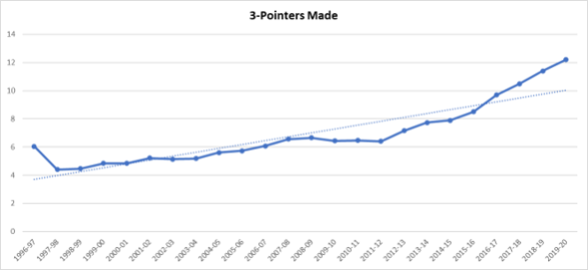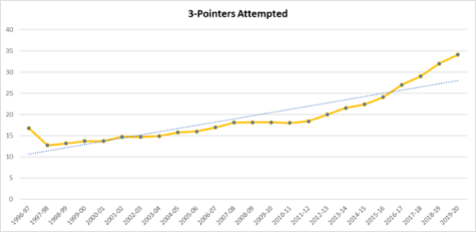

Fig. 3: Time series plot for 3- pointers attempted

Fig. 2: Time series plot for 3- pointers made

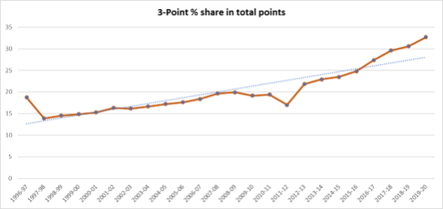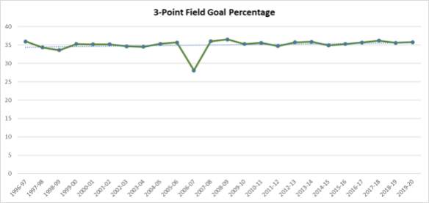

Fig. 5: Time series plot for 3- point % share in total points

Fig. 4: Time series plot for 3- point field goal percentage

1. **BOX PLOT**

The box plots show the variation of mean and medium in 3- point shooting across the NBA before and after the arrival of Stephen Curry. In this case, we note through concentration of boxes that post arrival of Stephen Curry, 3- point shooting has increased in terms of conversion, attempts and share in total points. There has also been a drastic improvement in shooting accuracy.

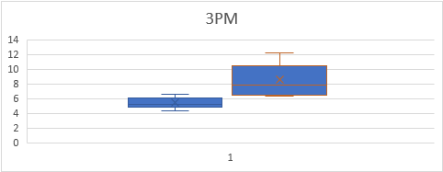

Fig. 6: Box plot for 3- pointers made

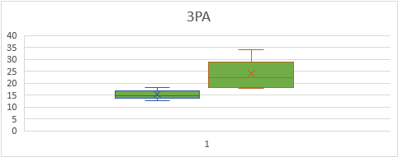

Fig. 7: Box plot for 3- pointers attempted

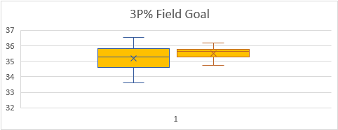

Fig. 8: Box plot for 3- point % in field goals

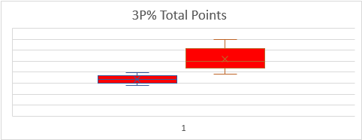

Fig. 9: Box plot for share of 3- point % in total points

1. **Histogram**

A histogram was plotted for each of the four criteria to depict the trend throughout the years.

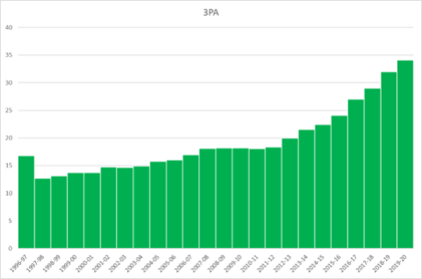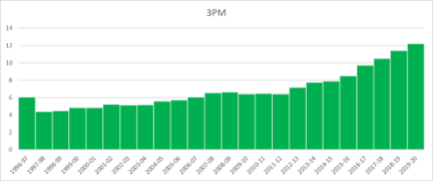

Fig. 11: Histogram for 3- pointers attempted vs season

Fig. 10: Histogram for 3- pointers made vs season

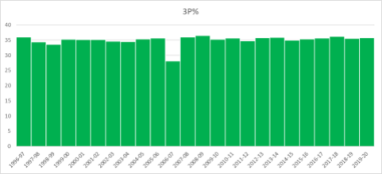

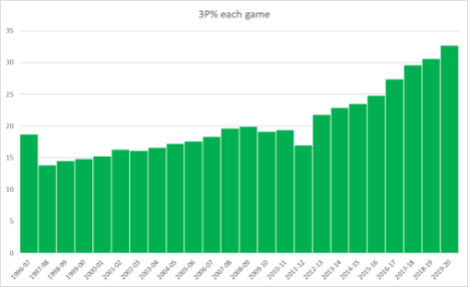

Fig. 13: Histogram for share of 3P % in total points vs season

Fig. 12: Histogram for 3- point % vs season

1. **t-Test (Hypothesis Testing)**

The above t-tests indicate 3 PM, 3PA, and 3P percentage share in each game that have values of P <0.05, leading us to reject the hypothesis that data is normally distributed. The testing was done on 2 sets of data before and after Steph Curry was predominant. Whereas the t-test for 3 point percentage field goals has a value of P = 0.229009, which is more than 0.05, pointing that the data is following a normal distribution.

|  |  |  |
| --- | --- | --- |
|  | *3PA (Before)* | *3PA (After)* |
| Mean | 15.33551 | 24.05788 |
| Variance | 3.21625 | 32.66471 |
| Observations | 13 | 11 |
| Hypothesized Mean Difference | 0 |  |
| df | 12 |  |
| t Stat | -4.86311 |  |
| P(T<=t) one-tail | 0.000195 |  |
| t Critical one-tail | 1.782288 |  |
| P(T<=t) two-tail | 0.000389 |  |
| t Critical two-tail | 2.178813 |  |

|  |  |  |
| --- | --- | --- |
|  | *3PM (Before)* | *3PM (After)* |
| Mean | 5.440548175 | 8.583333273 |
| Variance | 0.548365666 | 4.295649036 |
| Observations | 13 | 11 |
| Hypothesized Mean Difference | 0 |  |
| df | 12 |  |
| t Stat | -4.777750695 |  |
| P(T<=t) one-tail | 0.00022514 |  |
| t Critical one-tail | 1.782287556 |  |
| P(T<=t) two-tail | 0.000450281 |  |
| t Critical two-tail | 2.17881283 |  |

Table 4: t-test for 3- pointers attempted before and after Steph Curry

Table 3: t-test for 3- pointers made before and after Steph Curry

|  |  |  |
| --- | --- | --- |
|  | *3P% (Before)* | *3P% (After)* |
| Mean | 35.21028 | 35.52373 |
| Variance | 0.602038 | 0.190146 |
| Observations | 13 | 11 |
| Hypothesized Mean Difference | 0 |  |
| df | 19 |  |
| t Stat | -1.24294 |  |
| P(T<=t) one-tail | 0.114505 |  |
| t Critical one-tail | 1.729133 |  |
| P(T<=t) two-tail | 0.229009 |  |
| t Critical two-tail | 2.093024 |  |

|  |  |  |
| --- | --- | --- |
|  | *3P% each game (Before)* | *3P% each game(After)* |
| Mean | 16.86112 | 26.07824 |
| Variance | 3.782444 | 28.56151 |
| Observations | 13 | 11 |
| Hypothesized Mean Difference | 0 |  |
| df | 12 |  |
| t Stat | -5.42422 |  |
| P(T<=t) one-tail | 7.70E-05 |  |
| t Critical one-tail | 1.782288 |  |
| P(T<=t) two-tail | 0.000154 |  |
| t Critical two-tail | 2.178813 |  |

Table 6: t-test for 3- point % share in total points before and after Steph Curry

Table 5: t-test for 3- point % before and after Steph Curry

1. **ANOVA**

|  |  |  |  |  |  |  |
| --- | --- | --- | --- | --- | --- | --- |
| Anova: 3PM | | | | | | |
|  |  |  |  |  |  |  |
|  | SUMMARY |  |  |  |  |  |
|  | *Groups* | *Count* | *Sum* | *Average* | *Variance* |  |
|  | 3PM | 13 | 70.72713 | 5.440548 | 0.5483657 |  |
|  | 3PM | 11 | 94.41667 | 8.583333 | 4.295649 |  |
|  |  |  |  |  |  |  |
| *Source of Variation* | *SS* | *df* | *MS* | *F* | *P-value* | *F crit* |
| Between Groups | 58.85104 | 1 | 58.85104 | 26.136547 | 4.02E-05 | 4.300949502 |
| Within Groups | 49.53688 | 22 | 2.251676 |  |  |  |
|  |  |  |  |  |  |  |
| Total | 108.3879 | 23 |  |  |  |  |
|  |  | Table 7: ANOVA for 3- pointers made before and after Steph Curry |  |  |  | Conclusion: P value< 0.05, Null hypothesis Rejected |
|  |  |  |  |  |  |  |

|  |  |  |  |  |  |  |
| --- | --- | --- | --- | --- | --- | --- |
| Anova: 3PA | | | | | | |
|  |  |  |  |  |  |  |
|  | SUMMARY |  |  |  |  |  |
|  | *Groups* | *Count* | *Sum* | *Average* | *Variance* |  |
|  | 3PA | 13 | 199.3616 | 15.33551 | 3.2162502 |  |
|  | 3PA | 11 | 264.6367 | 24.05788 | 32.664711 |  |
|  |  |  |  |  |  |  |
| *Source of Variation* | *SS* | *df* | *MS* | *F* | *P-value* | *F crit* |
| Between Groups | 453.3087 | 1 | 453.3087 | 27.304603 | 3.06E-05 | 4.300949502 |
| Within Groups | 365.2421 | 22 | 16.60191 |  |  |  |
|  |  |  |  |  |  |  |
| Total | 818.5508 | 23 |  |  |  |  |
|  |  | Table 8: ANOVA for 3- pointers attempted before and after Steph Curry |  |  |  | Conclusion: P value< 0.05, Null hypothesis Rejected |

|  |  |  |  |  |  |  |
| --- | --- | --- | --- | --- | --- | --- |
| Anova:3P% | | | | | | |
|  |  |  |  |  |  |  |
|  | SUMMARY |  |  |  |  |  |
|  | *Groups* | *Count* | *Sum* | *Average* | *Variance* |  |
|  | 3P% | 13 | 457.7336 | 35.21028 | 0.6020377 |  |
|  | 3P% | 11 | 390.761 | 35.52373 | 0.1901459 |  |
|  |  |  |  |  |  |  |
| *Source of Variation* | *SS* | *df* | *MS* | *F* | *P-value* | *F crit* |
| Between Groups | 0.585412 | 1 | 0.585412 | 1.4112624 | 0.2475144 | 4.300949502 |
| Within Groups | 9.125912 | 22 | 0.414814 |  |  |  |
|  |  |  |  |  |  |  |
| Total | 9.711323 | 23 |  |  |  |  |
|  | Table 9: ANOVA for 3- point% before and after Steph Curry |  |  |  |  | Conclusion: P value> 0.05, Null hypothesis is accepted |

|  |  |  |  |  |  |  |
| --- | --- | --- | --- | --- | --- | --- |
| Anova: 3P% share in each game | | | | | | |
|  |  |  |  |  |  |  |
|  | SUMMARY |  |  |  |  |  |
|  | *Groups* | *Count* | *Sum* | *Average* | *Variance* |  |
|  | 3P% each game | 13 | 219.1945 | 16.86112 | 3.7824444 |  |
|  | 3P% each game | 11 | 286.8607 | 26.07824 | 28.561515 |  |
|  |  |  |  |  |  |  |
| *Source of Variation* | *SS* | *df* | *MS* | *F* | *P-value* | *F crit* |
| Between Groups | 506.1927 | 1 | 506.1927 | 33.643771 | 7.78E-06 | 4.300949502 |
| Within Groups | 331.0045 | 22 | 15.04566 |  |  |  |
|  |  |  |  |  |  |  |
| Total | 837.1972 | 23 |  |  |  |  |
|  |  | Table 10: ANOVA for 3- point % share in total points before and after Steph Curry |  |  |  | Conclusion: P value< 0.05, Null hypothesis Rejected |

1. **RESULTS AND DISCUSSIONS**

* ANOVA is conducted to evaluate the significance of Stephen Curry on the variation of 3-point shooting across the NBA. After performing the one-way ANOVA for 3-point shooting using MS EXCEL, we found that the p-value is minimal for three parameters which are 3 Pointers made, 3-pointers attempted, and percentage share of 3-pointers in total points, almost equivalent to 0. Since 0 < 0.05 ( α value), we reject the null hypothesis and accept the alternate hypothesis that at least one mean value is different.
* On the other hand, a single ANOVA test conducted on a 3-pointer field goal percentage gave us a p-value of 0.248 > 0.05 (α value), accepting the null hypothesis and indicating that the mean is almost similar.
* The influence of Stephen Curry on 3-point shooting across the leagues was predominantly noticed starting season 2012-13, mainly coinciding with his elevation as a role player for the Golden State Warriors which involved more ball handling, game time and freedom to shoot 3-pointers.
* Before 2012-13 growth in 3-point shooting was stagnant for more than 3 seasons indicating the influence of noise factors such as injuries, rookie season, and less game time.

1. **SCOPE OF WORK:**

The study of variation predominantly risen in 3-point shooting over the past 24 years regarding Stephen Curry's impact can substantially affect the NBA teams, basketball analysts, and fans. The exponential rise in 3-point shooting and its consideration in game plans draw considerable inspiration from Stephen Curry's heroics. Going by the trend, teams have started giving more importance to 3-point shooting in their game plan during the 2015-2016 season. No significant rise in accuracy can be noticed from the 3-point field goal percentage since players were given more freedom to shoot the same.

The analysis of 3- point shooting regarding Stephen Curry's impact paves the way for evaluating the 3-point shooting across the NBA.

1. **REFERENCES**

1) https://www.nba.com/stats/teams/traditional/?sort=W_PCT&dir=-1

2) https://en.wikipedia.org/wiki/Stephen_Curry

3) https://www.basketball-reference.com/players/c/curryst01.html